**Web 4 Assignment #2: PHP + Arrays**

*Due 04 Mar*

***Overview***

The intent of this assignment is to demonstrate your mastery of arrays in PHP. The assignment is worth 10 points. You have been provided with a folder named assign_02 which contains the main index file as well as four other files namely travel-data.php, travel-footer.php, travel-header.php, travel-image.php and travel-left-rail.php.

***Submitting***

Put your assignment in a folder named assign_02_*yourFullName*. Put all resources used by your assignment into this folder. Zip and submit this folder to D2L. You will lose marks if you do not follow these submission instructions.

***Grading***

The grade for this assignment will be broken down as follows:

Functional Requirements (85/100)

Non-Functional Requirements (15/100)

***Non-Functional Requirements***

You must write PHP code in the following files for reading and manipulating arrays:

* index.php
* travel-image.php
* travel-left-rail.php

***Functional Requirements: Main Page***

1. The main page (index.php) will eventually contain thumbnails for a variety of travel images as shown in Figure 1 and a page that will eventually display the details of a single travel image (travel-image.php).
2. Clicking a thumbnail in the first file will take you to the second page where you will be able to see details for that image, as shown in the Figure 2.

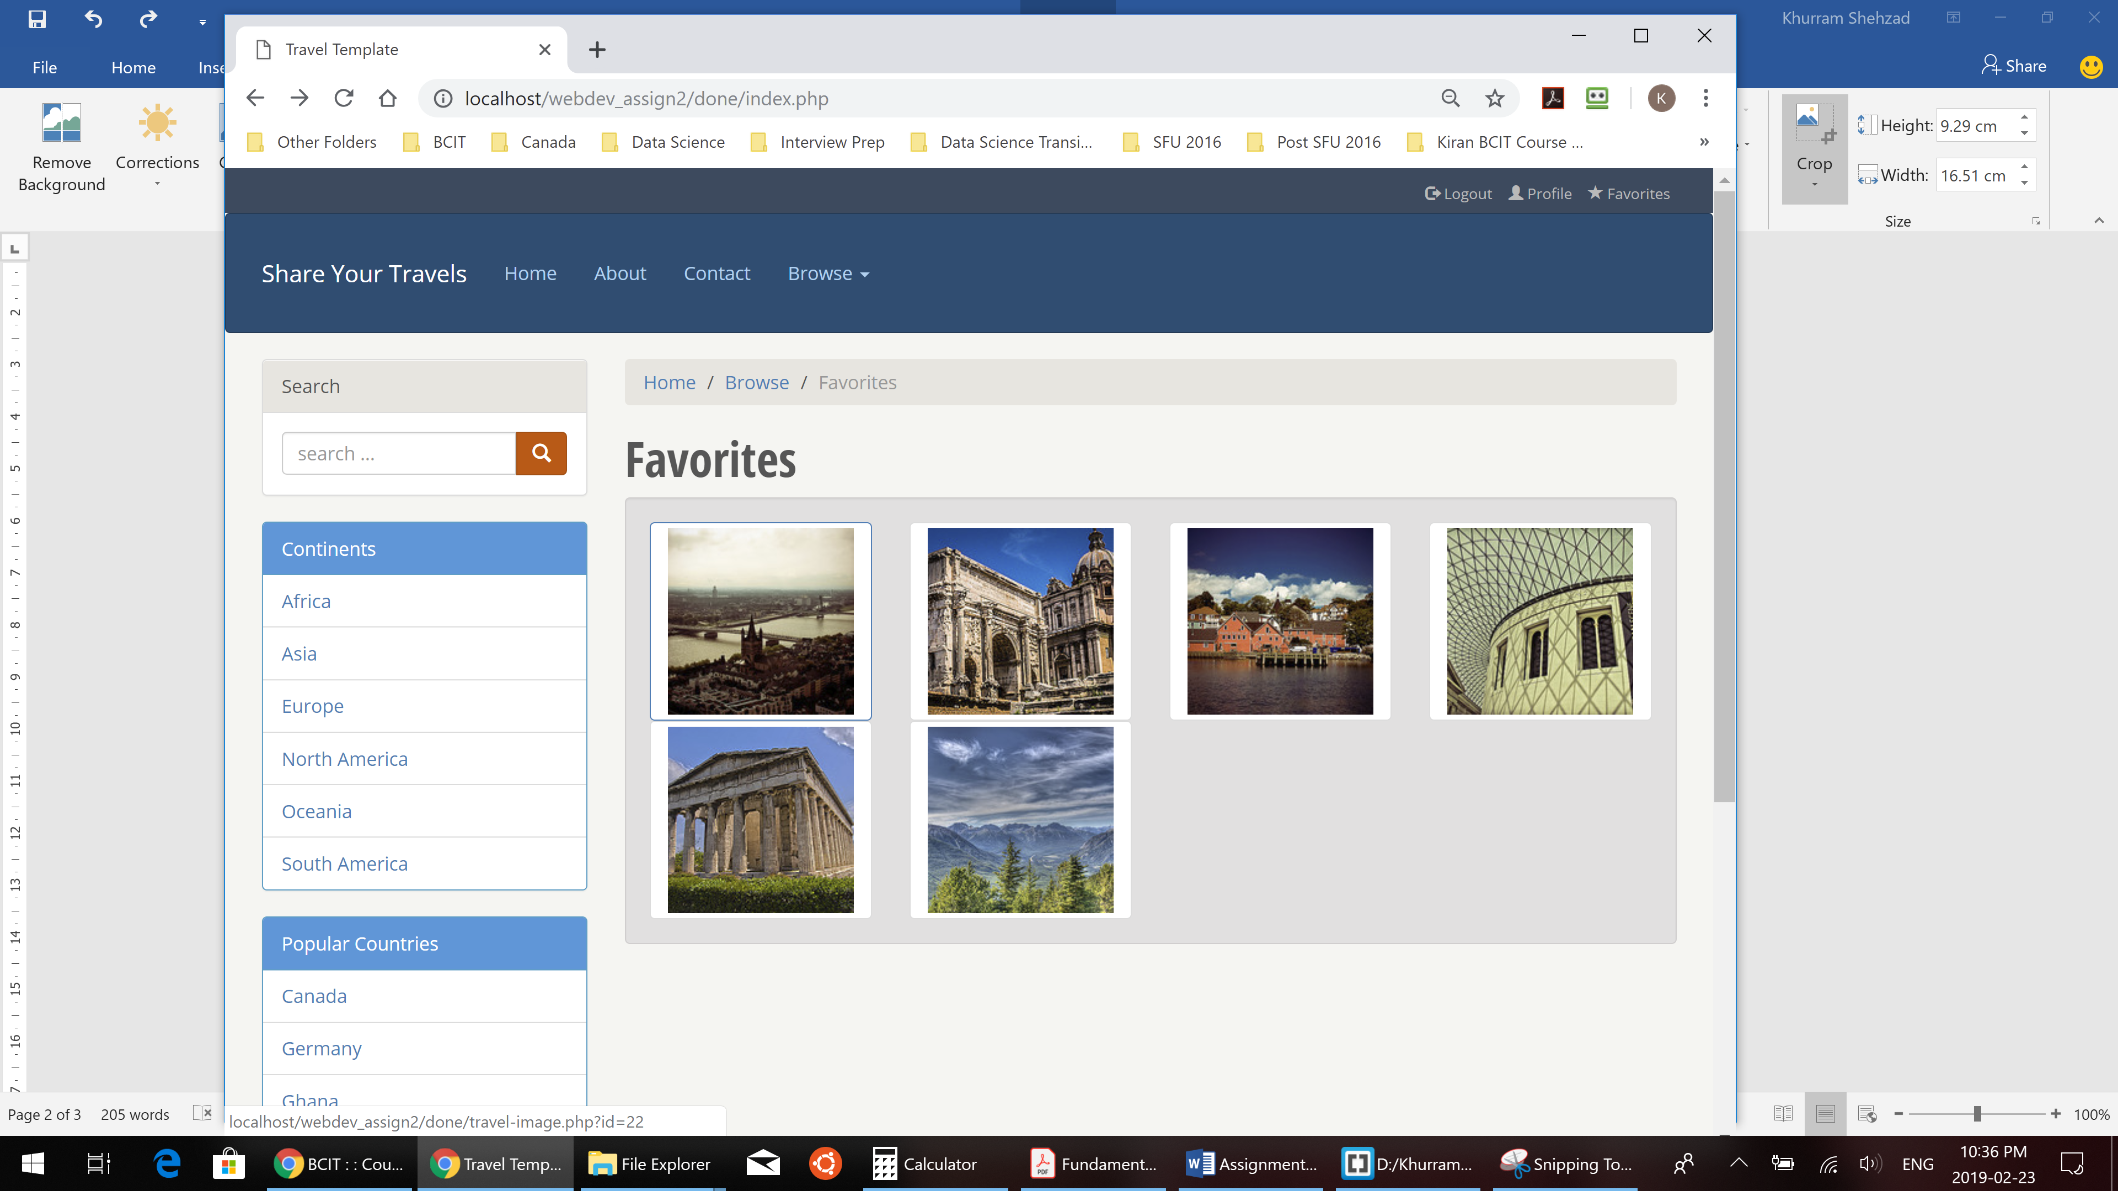

Notice that links for each thumbnail include id as query string parameter.

**FIGURE 1**

Write a loop that displays these images and links using data within the $images array defi­ned in travel­data.php.

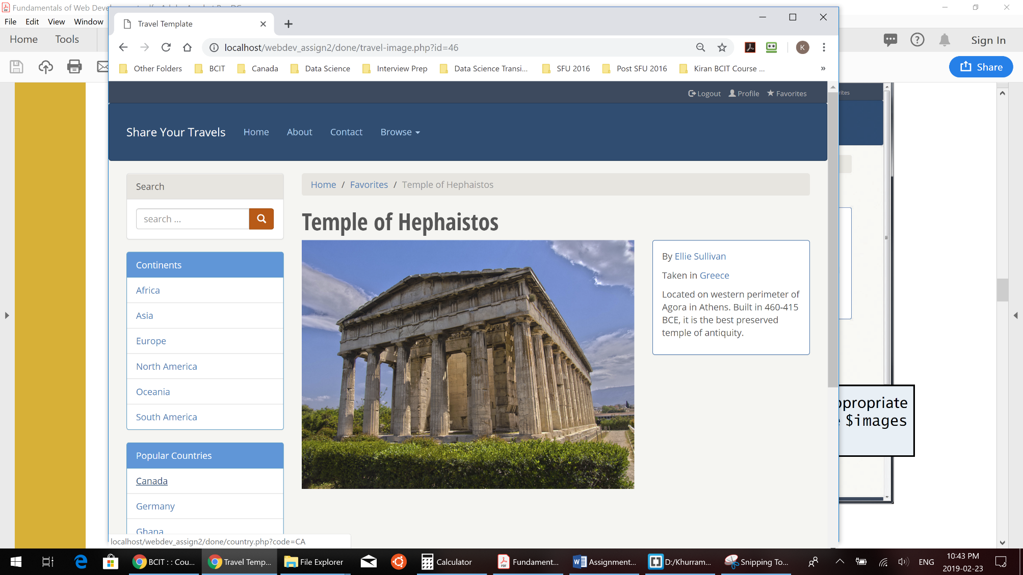

Notice that links for countries need to include the country code as a query string parameter.

Display the appropriate data from the $images array.

Write loops to display these menus using the arrays defi­ned within travel­data.php. Also use the appropriate PHP sort functions.

**FIGURE 2**